## VeraCrypt - Cognitive Walkthrough

VeraCrypt is an open-source utility software for establishing and maintaining on-the-fly encryption (OTFE). It can create a virtual encrypted disk within a file or encrypt a partition or the entire storage device with pre-boot authentication.

On-the-fly encryption means that data is automatically encrypted right before it is saved and decrypted right after it is loaded, without any user intervention.

No data stored on an encrypted volume can be read (decrypted) without using the correct password/keyfile(s) or correct encryption keys. Entire file system is encrypted (e.g., file names, folder names, contents of every file, free space, meta data, etc).

Core Tasks -

CT1 – Successfully installed VeraCrypt and its components

CT2 -

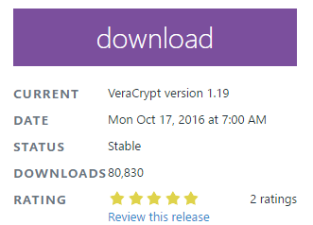G1 - Easy download - <https://veracrypt.codeplex.com/> - website to download Veracrypt and click this Download button

G1, G6 and G7 – Wizard installation – good, also G4 – options to navigate back and forth

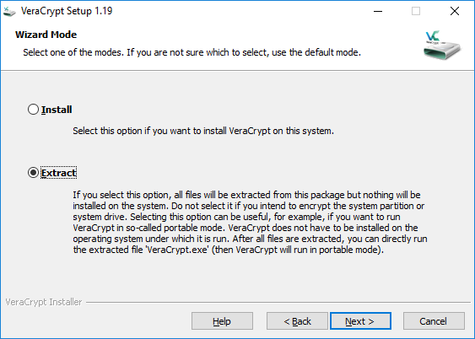

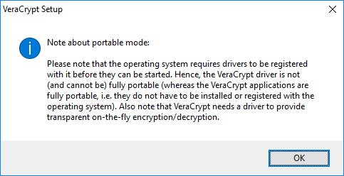Warnings are displayed for user to know the next step or effects of choosing options - good

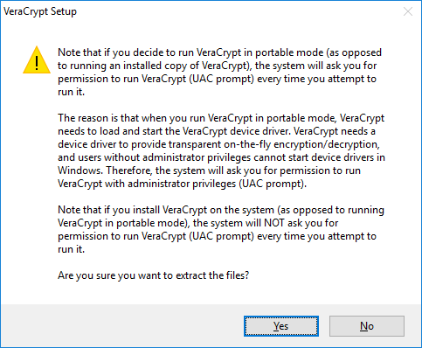

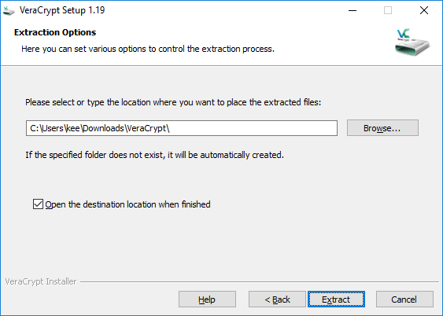

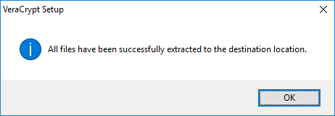G3 – good

But no shortcuts created on desktop or no option asking it so user may get confused what to choose to launch

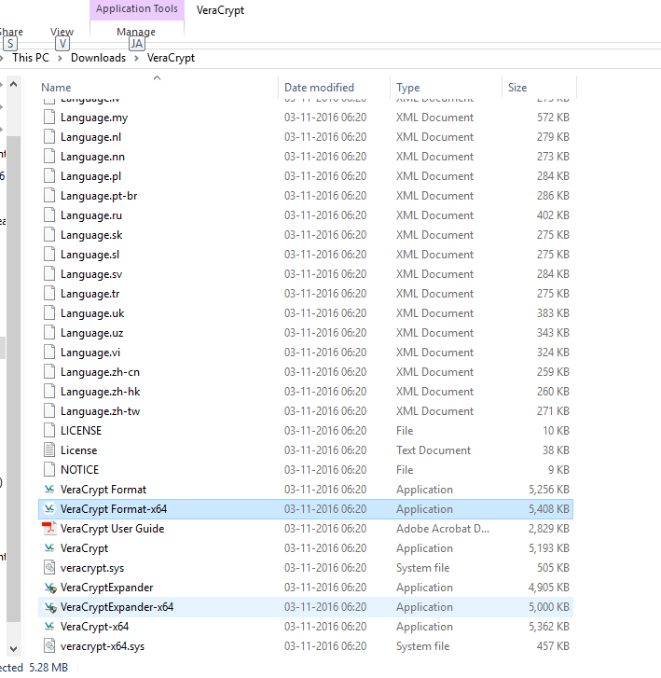

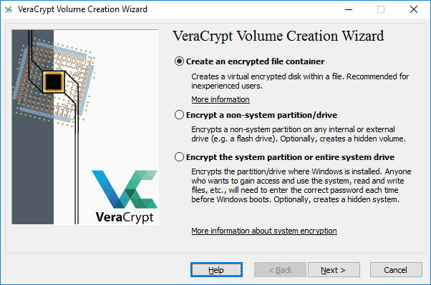

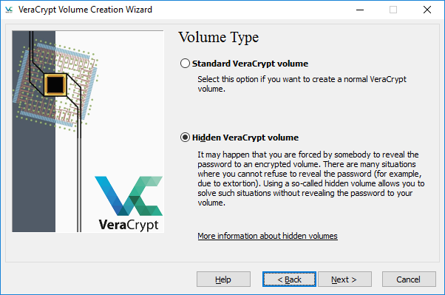

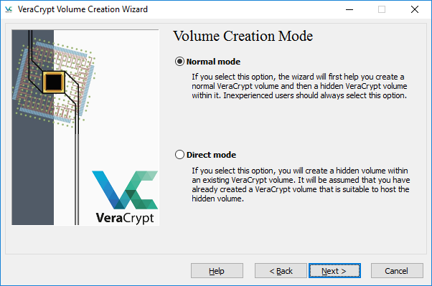

G1 , G4 , G5 , G6 Too many options to select - installation takes long time , good for first time users

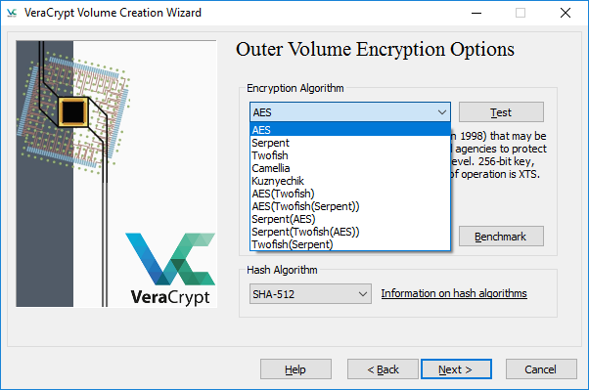

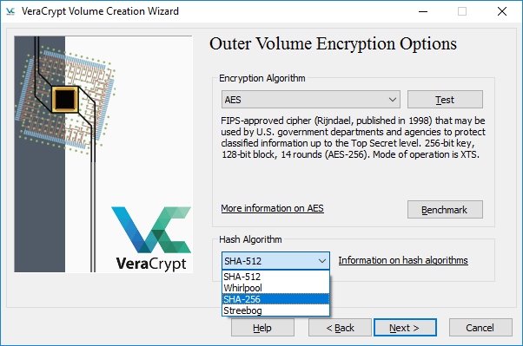

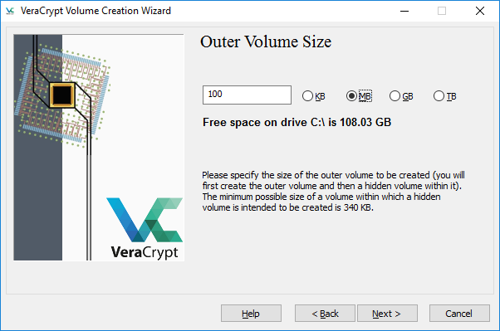

User can choose encryption algorithm and hash Algorithm advantage but users having no knowledge on encryptions would be confused what to choose – better to keep note like - ‘ If you are not sure what to select here, you can use the default settings and click Next’ as mentioned in user guide.

User is Able to choose volume size and note on minimum size to be chosen is mentioned – good.

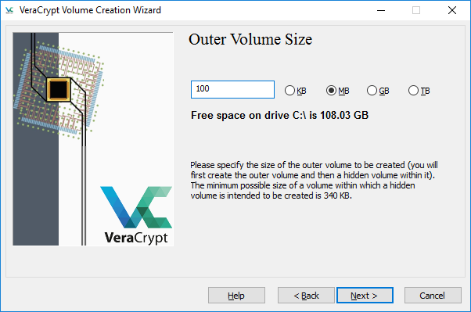

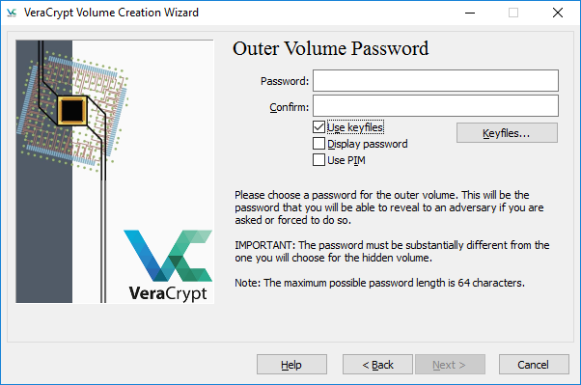G4 , G2 – more level of security

User can add keyfiles too, also option to generate Random key file is provided by Software but randomness is created by mouse movements it may be irritating for user to move mouse for 30 seconds!

G3 – After generating random keyfile

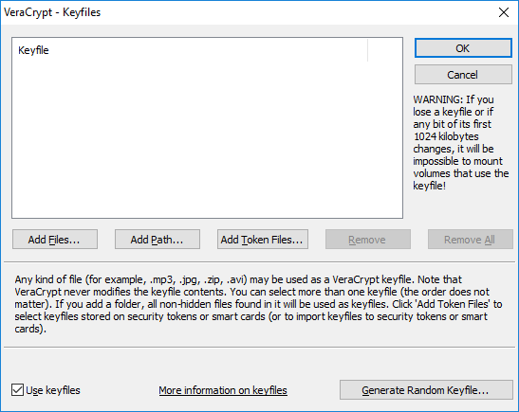

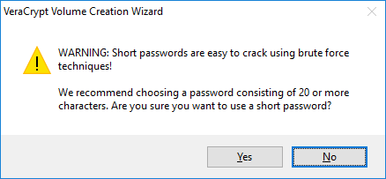Warning mentioning about password strength – good

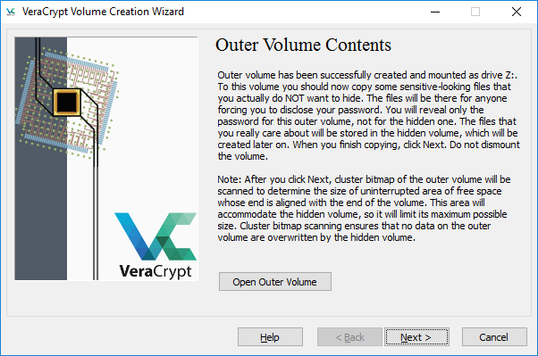

G6 – Too much content user may not read this

G7 – User may not be comfortable as to repeat the same steps to create hidden volume -Lengthy installation and configuration.

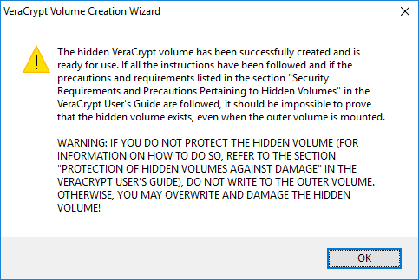

G3 , G6 – good